1

a

i

[10 8 20 4] ^ T = [2.5 2 5 1] ^ T in homogeneous coordinates

b

i)

Find a transformation A that can transform the line so that it is align with any of the x, y or z axis

Use the standard rotation matrix to rotate the point Ax

Transform it back to the original coordinate using A^{-1}

A^{-1} \theta A x

where A is previous mention transformation

x is the coordinate of the point

\theta is the standard rotation matrix depending on the axis and the angle

ii

Rotate the line to the y-z plane

Rotate the line so that it is aligned with the y-axis

Note that since r_0 is in the origin, no translation is needed, if not we will first need to translate r_0 to the origin.

We first rotate d along y-axis anticlockwise for $θ$ where $θ$ is arctan(2 / 8)

which means we have the transformation matrix:

[[4 / sqrt(17) 0 1 / sqrt(17) 0],

[0 1 0 0],

[-1 / sqrt(17) 0 4 / sqrt(17) 0 ],

[0 0 0 1]]

We then rotate the line about x-axis clockwise 90 degree

[[1 0 0 0],

[0 0 1 0],

[0 -1 0 0],

[0 0 0 1]]

And then we multiply the two matrices together.

iii)

Use the matrix:

[[sqrt(2) / 2 0 -sqrt(2) / 2 0],

[0 1 0 0],

[sqrt(2) / 2 0 sqrt(2) / 2 0],

[0 0 0 1]]

for rotation about y axis and to achieve the result you just chain the matrices together as mentioned in i

c

From the first column, we know [1 0 0 0]^T -> [-1 0 0 0]

From the second column, we know [0 1 0 0]^T -> [0 0 -1 0]

From the third column, we know [0 0 1 0]^T -> [0 -1 0 0]

From the fourth column, we know no scaling is performed

TODO: please help on the effect of this transformation done on the graphics scene.

The scene is first rotated 180 degree around the z-axis, then it is rotated 90 degree around the new x-axis (90 degree clockwise when viewing toward the positive x-axis)

2.

a)

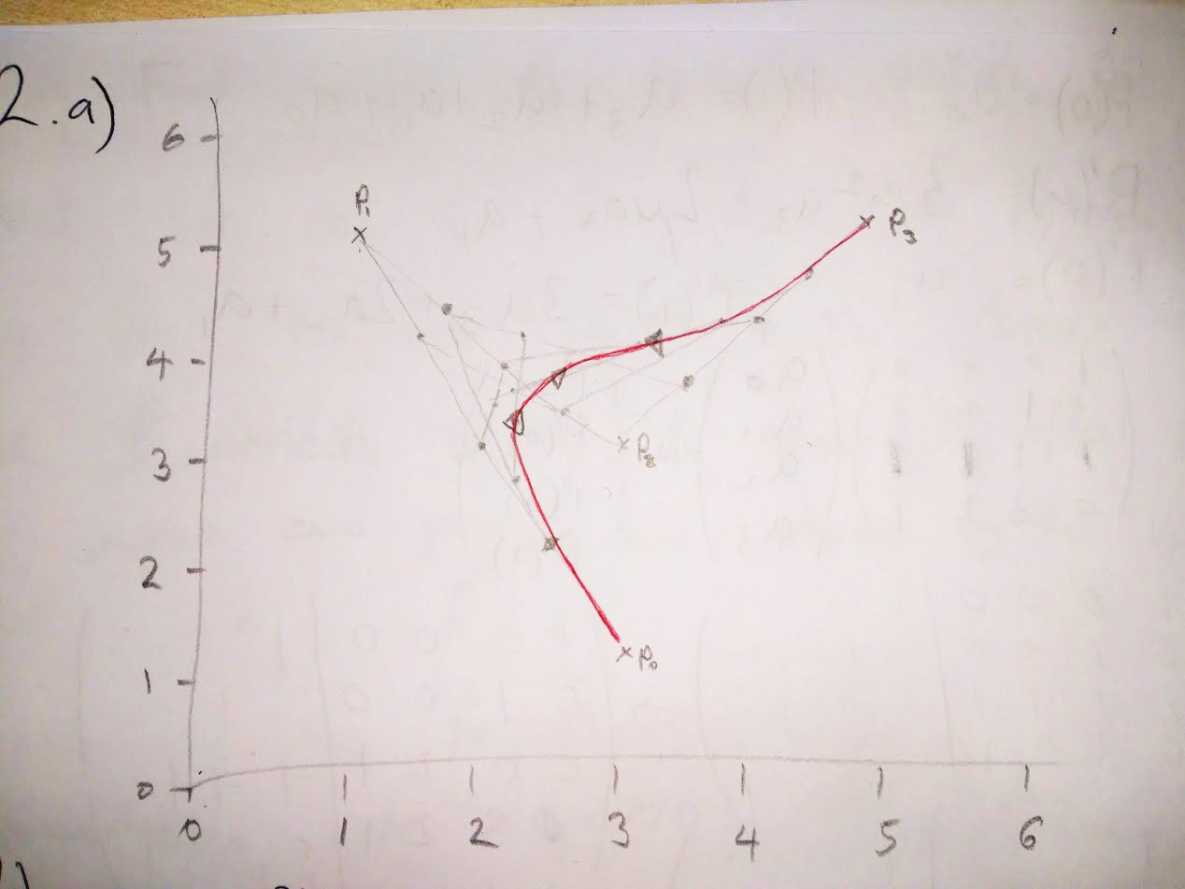

|  |  |
| --- | --- |
| mu | point |
| 0.25 | (2.1875, 3.03125) |
| 0.5 | (2.5, 3.75) |
| 0.75 | (3.5625, 4.09375) |

b)

p(μ) = (1-μ)^3 P0 + 3μ(1-μ)^2 P1 + 3μ^2(1-μ) P2 + μ^3 P3

p(⅓) = ( 13/9 13/9 )^T

p(⅔) = ( 19/9 7/3 )^T

c)

p’(μ) = -3(1-μ)^2 P0

* 3[(1-μ)^2 - 2μ(1-μ)] P1
* 3[2μ(1-μ) - μ^2] P2
* 3μ^2 P3

p’(½) = ( -3/2 -3 )^T

d) i. Done in slides

ii. (not 100% sure – someone confirm?)

4 point bezier goes through P_0, P_1,P_2, P_3

So subbing:

P_i = P_1

P_i+1 = P_2

P’_i = P’_1 = ½(P_2-P_0)

P’_i+1 = P’_2 = ½(P_3-P_1)

Into the equations found for part d)i) should give the a0,a1,a2,a3 required to define the curve.

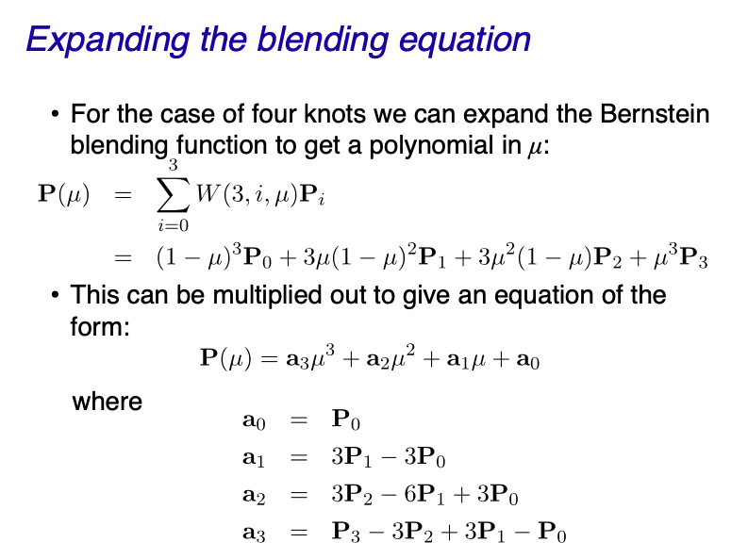

3) ?

4) ?